Stereo Discotheque (4M 046-94.687)

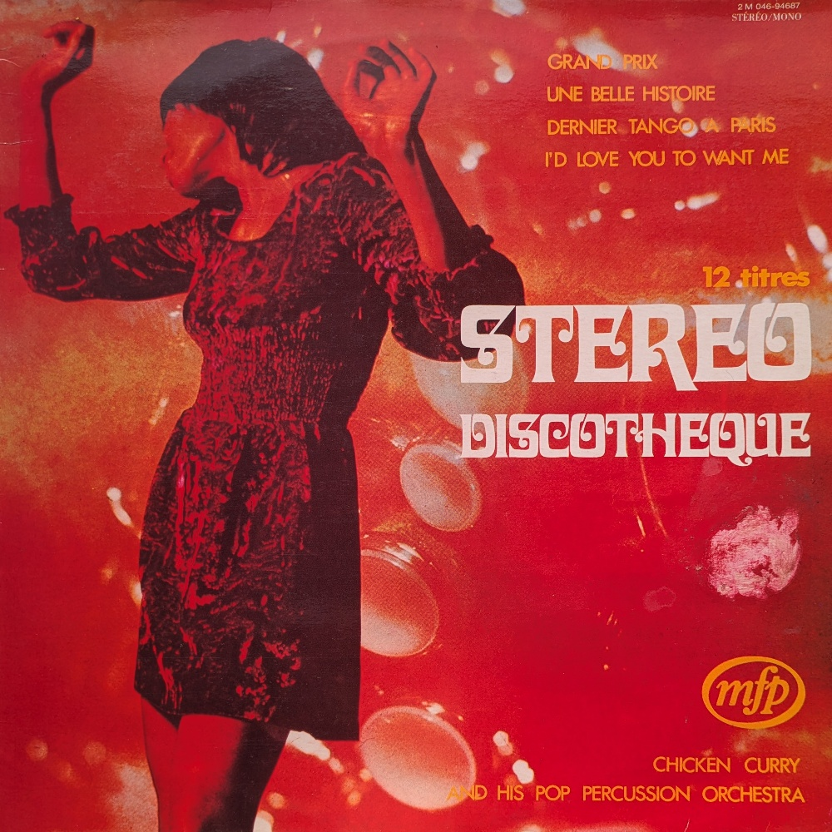
I don’t think record is widely known which is a shame because it is a gem of the MFP catalogue, released only in France and Italy – which is perhaps why it is overlooked in the UK.

MFP’s launch in France in 1970 was met with strong opposition from record dealers, who feared the low-priced albums would undermine the traditional market. Jacques Le Calve, president of the French Syndicat des Disquaires, called for a semiboycott of the Pathé-Marconi-backed label, arguing that customers accustomed to paying 11.50 francs for a quality LP would be reluctant to buy full-priced releases. Despite the resistance, MFP continued its expansion plans and thank goodness because it threw up this little treasure.

The album is credited to Chicken Curry & His Pop Percussion Orchestra; a fake French-market alias for El Chicles, a Belgian jazz-funk outfit whose two main members, John Sluszny and Ralph Benatar, were both prolific composers working within a tight-knit circle of Brussels session musicians who put out dozens of records under various pseudonyms throughout the early 1970s. One of the tracks on the album, Librium, also appears on the RKM library record Beat Action.
There is a significant crossover between the worlds of Music for Pleasure and that of the music library. There are some MFP consumer reissues of library albums, Tijuana Christmas was originally Christmas Party (KPM 1502), and a significant overlap of personnel across both budget label and production library output.
The track Malaria Fever on this album also appears on the MFP album Brasil, where it shows up as Malaria Febre, a slightly altered, even Moog-ier version of the track on this record.

